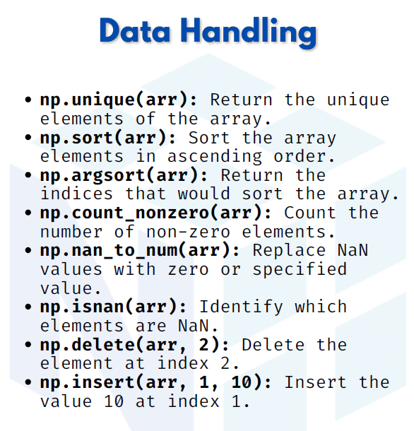

Data handling
1. np.unique(arr) → Returns unique elements of the array

import numpy as np
arr = np.array([1, 2, 2, 3, 4, 4, 5])
unique_values = np.unique(arr)
print("Unique elements:", unique_values)
Output:
Unique elements: [1 2 3 4 5]

2. np.sort(arr) → Sorts the array in ascending order
arr = np.array([5, 2, 8, 1, 3])
sorted_arr = np.sort(arr)
print("Sorted array:", sorted_arr)
Output:
Sorted array: [1 2 3 5 8]

3. np.argsort(arr) → Returns the indices that would sort the array
arr = np.array([40, 10, 20, 30])
indices = np.argsort(arr)
print("Indices that would sort the array:", indices)
Output:
Indices that would sort the array: [1 2 3 0]
4. np.count_nonzero(arr) → Counts the number of non-zero elements
arr = np.array([0, 2, 0, 5, 6, 0, 9])
count = np.count_nonzero(arr)
print("Number of non-zero elements:", count)
Output:
Number of non-zero elements: 4

5. np.nan_to_num(arr, nan=0) → Replaces NaN values with 0
arr = np.array([1, np.nan, 2, np.nan, 3])
cleaned = np.nan_to_num(arr, nan=0)
print("After replacing NaN:", cleaned)
Output:
After replacing NaN: [1. 0. 2. 0. 3.]

6. np.isnan(arr) → Returns a boolean array showing NaN positions
arr = np.array([10, np.nan, 20, 30, np.nan])
nan_mask = np.isnan(arr)
print("NaN positions:", nan_mask)
Output:
NaN positions: [False True False False True]

7. np.delete(arr, index) → Deletes element at given index
arr = np.array([10, 20, 30, 40, 50])
new_arr = np.delete(arr, 2) # delete element at index 2 (30)
print("After deletion:", new_arr)
Output:
After deletion: [10 20 40 50]

8. np.insert(arr, index, value) → Inserts a value at a given index
arr = np.array([10, 20, 40, 50])
new_arr = np.insert(arr, 2, 30) # insert 30 at index 2
print("After insertion:", new_arr)
Output:
After insertion: [10 20 30 40 50]

